A MINI PROJECT REPORT

**On**

**EYE PRECAUTIONARY DEVICE**

**UTSAH**

**(171500365)**

**PRADYUMN KUMAR**

**(171500221)**

Department of Computer Engineering & Applications

**Institute of Engineering & Technology**



**GLA University**

**Mathura- 281406**

**2020-2021**

**Department of Computer Engineering and Applications**

**GLA University, Mathura**

**17 km. Stone NH#2, Mathura-Delhi Road, P.O. – Chaumuha,**

**Mathura – 281406**



**Declaration**

We hereby declare that the work which is being presented in the Mini Project “**Eye precautionary device using Iot Tools”,**in partial fulfillment of the requirements for Mini-Project, is an authentic record of our own work carried under the supervision of**Mr. Amir khan(Technical trainer) GLA University, Mathura**.

**Name of Candidate1:**

**Signature of Candidate1:**

**Name of Candidate2:**

**Signature of Candidate2:**



**Department of Computer Engineering and Applications**

**GLA University, Mathura**

**17 km. Stone NH#2, Mathura-Delhi Road, P.O. – Chaumuha,**

**Mathura – 281406**

**CERTIFICATE**

This is to certify that the project entitled **“*Eye precautionary device*”** carried out in Mini Project is abonafidework done by ***Utsah (Univ. Roll no. 171500365)*,*Pradyumn Kumar (Univ. Roll no. 171500221)*** are submitted in partial fulfillment of the requirements for the award of the degree Bachelor of Technology in Computer Science & Engineering.

**Name of Supervisor:**

**Mr. Amir khan**

**(Mini Project Mentor)**

**Signature with date:**

**ACKNOWLEDGEMENT**

*It gives us a great sense of pleasure to present the report of the B. Tech Mini Project undertaken during B. Tech. Third Year. This project in itself is an acknowledgement to the inspiration, drive and technical assistance contributed to it by many individuals. This project would never have seen the light of the day without the help and guidance that we have received.*

*Our heartiest thanks to* ***Prof. (Dr.) Anand Singh Jalal,*** *Head of Dept., Department of CEA for providing us with an encouraging platform to develop this project, which thus helped us in shaping our abilities towards a constructive goal.*

*We owe special debt of gratitude to* ***Mr.Amir khan,****technical trainer Department of CEA, for his constant support and guidance throughout the course of our work. His sincerity, thoroughness and perseverance have been a constant source of inspiration for us. He has showered us with all his extensively experienced ideas and insightful comments at virtually all stages of the project & has also taught us about the latest industry-oriented technologies.*

*We also do not like to miss the opportunity to acknowledge the contribution of all faculty members of the department for their kind guidance and cooperation during the development of our project. Last but not the least, we acknowledge our friends for their contribution in the completion of the project.*

*Utsah*

*Pradyumn kumar*

**TABLE OF CONTENTS**

|  |  |  |
| --- | --- | --- |
|  | **TITLE** | **PAGE NO.** |
|  | **ABSTRACT** | 6 |
| **1.** | **Problem Statement** | 7 |
| **2.** | **System design** | 7 |
|  | **2.1 pin diagram** | 9 |
|  | **2.2 Main working** | 11 |
| **3.** | **Requirement Specifications** | 14 |
|  | **3.1 Arduino** | 15 |
|  | **3.2Ultrasonic sensor** | 19 |
|  | **3.3 Breadboard** | 20 |
| **4.** | **Future Enhancement** | 22 |
| **5.** | **Refrences** | 22 |
| **6.** | **Code of project** | 23 |

### Abstract :

The project **“EYE PRECAUTIONARY DEVICE”** best describes a caring device for a family in today’s scenario,where people generally forgot to take care of themselves in the hustle bustle of their life’s burden.Main moto of our project to take care of people who are fond of watching tv,also for those who are not.This simple alarms individual to take care of his/her eyes while watching tv. This device simply alarms one to maintain a distance from a **PC,DEKSTOP**if one isExtremely near to it.

Reason behind that is increasing eye problems among kids,adults.old ones .All of them forget to maintain a prefereable distance from a **PC,DESKTOP ETC**.To avoid such type of problems among them ,we make up our mind to build such a device which alarms them for maintaining distance.

### In this project, we have developed a eye precautionary device using a node mcu 8266.We have used ultrasonic sensors in them for sensing purpose.Whenever any individual gets close to a screened object such as television,desktop,big screens ,there will be a led flash in the device that the individual is too close to the gadget.And that led will continue to glow until the persons maintains an permitted distance with the object.This device is of great use for the childrens,generally they don’t notice their distance from tv and pc. With the help of this project,parents and children themselves can take care of eyes.

In india, eye protective technologies has not come in Indian smart tv.So,only solution is that protecting ourself from the rays.

### 1) Problem Statement:

To implement a eye precautionary device microcontroller based platform Arduino Uno board which is interfaced with Ultrasonic sensor which can gives the status of the distamce of tv with individual.

**2)System design:**

### 

### Fig: led will stop glowing when object is away from tv.

### 

**Fig:led will start to glow when near to tv.**

This Eye precautionary device will have an  **Ultrasonic sensor to sense distance from any television, LDR to sense lighting conditions**. All the feedbacks will be given to the man through a LED.. Of course you can use a vibrator motor in place of Buzzer and advance a lot more using your creativity.

For a better understanding of project ,here is the circuit diagram

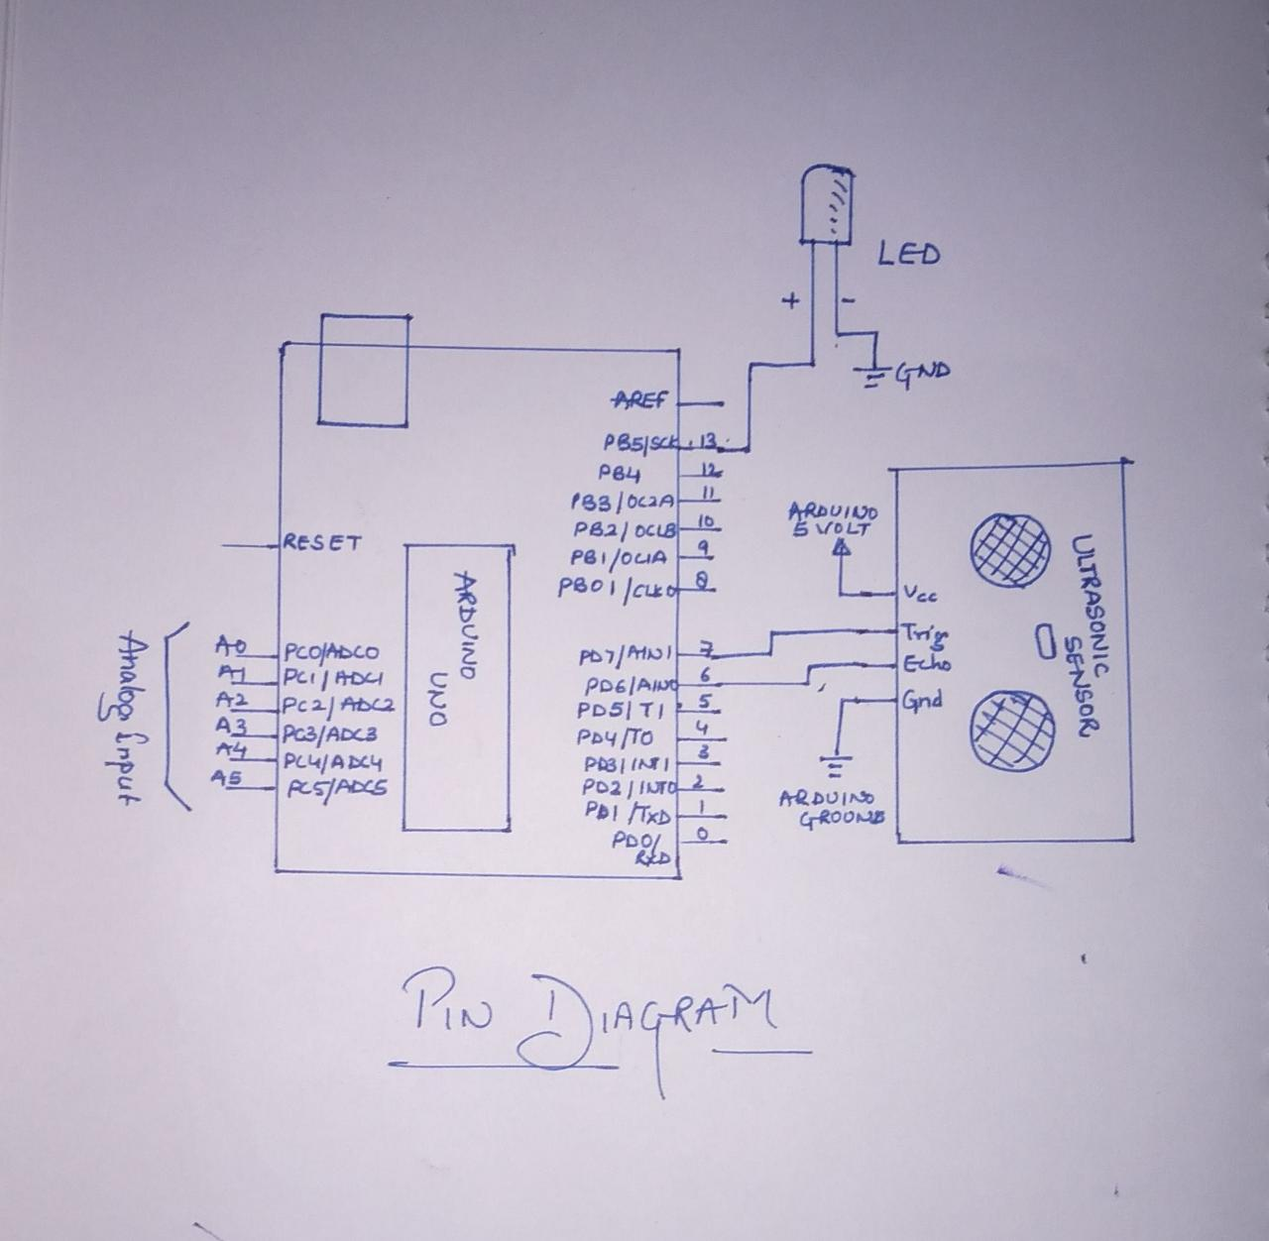

The hardware part of this project is very easy to put together. First of all, make the connections for the ultrasonic sensor with the Arduino. The connections for the ultrasonic sensor with the Arduino are as follows:

* Connect VCC on the ultrasonic sensor to the 5V pin on the Arduino.
* Connect the Trig pin on the ultrasonic sensor to pin 2 on the Arduino.
* Connect the Echo pin on the ultrasonic sensor to pin 3 on the Arduino.
* Connect the GND on the ultrasonic sensor to GND on the Arduino.

Now we will connect the LED with arduino uno.

* First we connect the positive leg(bigger leg) with 13th pin of arduino.
* Then we connect the negative leg(shorter leg) with ground pin of arduino uno.

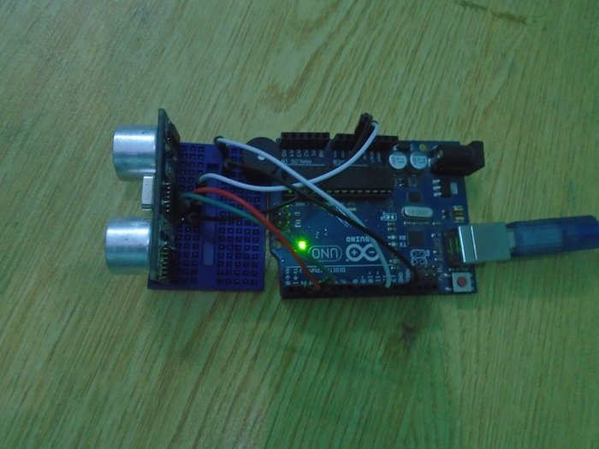

After this set up,we will connect the system with the pc using usb cable.With the help of any operating system and a suppprted arduino IDE,we will run the embedded c code on the IDE and check for the output.

After the successfull compilation of code in the IDE,we will check our project within a range mentioned in our code.

We have mentioned 1m precautionary distance in our code.

**Main working of project-**

Whenever the individual is less than or equal to 1m distance from tv/desktop,ultra sonic sensor sense it and gives a signal to arduino and arduino will let the LED to glow.

This gives a alarm to indivitial that he is too close to tv or desktop.and he should maintain a distance more than 1m.

This is the whole mechanism of this project.

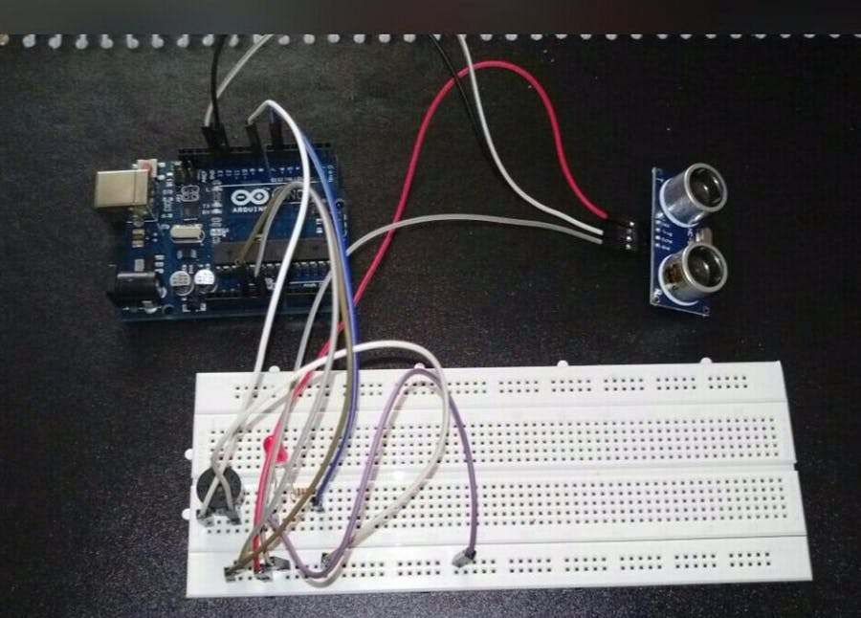

### 

### 3) Requirement Specification:

Eye precautionary device is built on Arduino board platform. It is interfaced with Ultrasonic sensor (HC-SR04) .

**3.1) Components Used:**

1) Arduino

2) Ultrasonic senor

3) Breadboard

4) Connecting wires

### 5) Any Operating System

6) arduino ide

**1.ARDUINO**

community that designs and manufactures [microcontroller](https://en.wikipedia.org/wiki/Microcontroller) kits for building digital devices and interactive objects that can sense and control objects in the physical world. The project's products Arduino is an open source, computer hardware and software company, project, and user are distributed as [open-source hardware](https://en.wikipedia.org/wiki/Open-source_hardware) and [software,](https://en.wikipedia.org/wiki/Open-source_software) which are licensed under the GNU Lesser General Public License(LGPL) or the GNU GeneralPublic License (GPL), permitting the manufacture of Arduino boards and software distribution by anyone. Arduino boards are available commercially in preassembled form, or as [do-it-yourself](https://en.wikipedia.org/wiki/Do-it-yourself) kits. Arduino board designs use a variety of microprocessors and controllers. The boards are equipped with sets of digital and analog [input/output](https://en.wikipedia.org/wiki/Input/output) (I/O) pins that may be interfaced to various expansion boards (*shields*) and other circuits. The boards feature serial communications interfaces, including [Universal Serial Bus](https://en.wikipedia.org/wiki/Universal_Serial_Bus) (USB) on some models, which are also used for loading programs from personal computers.[3]

Arduino/Genuino Uno is a microcontroller board based on the ATmega328P [(datasheet)](http://www.atmel.com/Images/doc8161.pdf). It has 14 digital input/output pins (of which 6 can be used as PWM outputs), 6 analog inputs, a 16 MHz quartz crystal, a USB connection, a power jack, an ICSP header and a reset button. It contains everything needed to support the microcontroller; simply connect it to a computer with a USB cable or power it with a AC-to-DC adapter or battery to get started. You can tinker with your UNO without worrying too much about doing something wrong, worst case scenario you can replace the chip for a few dollars and start over again. "Uno" means one in Italian and was chosen to mark the release of Arduino Software (IDE) 1.0. The Uno board and version 1.0 of Arduino Software (IDE) were the reference versions of Arduino, now evolved to newer releases. The Uno board is the first in a series of USB Arduino boards, and the reference model for the Arduino platform; for an extensive list of current, past or outdated boards see the Arduino index of boards.

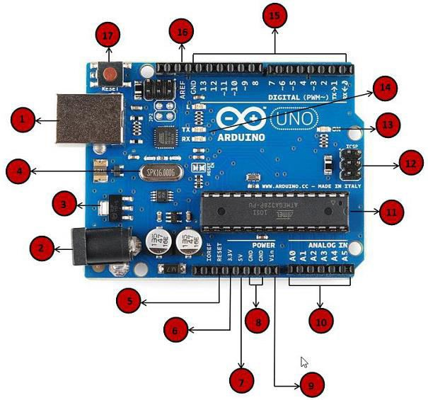

Fig 5: Pin diagram of Arduino

1. **Power USB:**Arduino board can be powered by using the USB cable from your computer. All you need to do is connect the USB cable to the USB connection
2. **Power (Barrel Jack)**:

Arduino boards can be powered directly from the AC mains power supply by connecting it to the Barrel Jack.

1. **Voltage Regulator**:

The function of the voltage regulator is to control the voltage given to the Arduino board and stabilize the DC voltages used by the processor and other elements.

1. **Crystal Oscillator**:

The crystal oscillator helps Arduino in dealing with time issues. How does Arduino calculate time? The answer is, by using the crystal oscillator. The number printed on top of the Arduino crystal is 16.000H9H. It tells us that the frequency is 16,000,000 Hertz or 16 MHz.

**(v, xvii) Arduino Reset:**

You can reset your Arduino board, i.e., start your program from the beginning. You can reset the UNO board in two ways. First, by using the reset button (17) on the board. Second, you can connect an external reset button to the Arduino pin labelled RESET (5).

**(vi, vii, viii, ix) Pins (3.3, 5, GND, Vin)**:

* 3.3V (6) − Supply 3.3 output volt.
* 5V (7) − Supply 5 output volt .
* Most of the components used with Arduino board works fine with 3.3 volt and 5 volt.
* GND (8)(Ground) − There are several GND pins on the Arduino, any of which can be used to ground your circuit.
* Vin (9) − This pin also can be used to power the Arduino board from an external power source, like AC mains power supply.

1. **Analog pins**: The Arduino UNO board has five analog input pins A0 through A5. These pins can read the signal from an analog sensor like the humidity sensor or temperature sensor and convert it into a digital value that can be read by the microprocessor.
2. **Main microcontroller**: Each Arduino board has its own microcontroller (11). You can assume it as the brain of your board. The main IC (integrated circuit) on the Arduino is slightly different from board to board. The microcontrollers are usually of the ATMEL Company. You must know what IC your board has before loading up a new program from the Arduino IDE. This information is available on the top of the IC. For more details about the IC construction and functions, you can refer to the data sheet.
3. **ICSP pin**: Mostly, ICSP (12) is an AVR, a tiny programming header for the Arduino consisting of MOSI, MISO, SCK, RESET, VCC, and GND. It is often referred to as an SPI (Serial Peripheral Interface), which could be considered as an "expansion" of the output. Actually, you are slaving the output device to the master of the SPI bus.
4. **Power LED indicator**: This LED should light up when you plug your Arduino into a power source to indicate that your board is powered up correctly. If this light does not turn on, then there is something wrong with the connection.
5. **TX and RX LEDs:** On your board, you will find two labels: TX (transmit) and RX (receive). They appear in two places on the Arduino UNO board. First, at the digital pins 0 and 1, to indicate the pins responsible for serial communication. Second, the TX and RX led (13). The TX led flashes with different speed while sending the serial data. The speed of flashing depends on the baud rate used by the board. RX flashes during the receiving process.
6. **Digital I/O**: The Arduino UNO board has 14 digital I/O pins (15) (of which 6 provide PWM (Pulse Width Modulation) output. These pins can be configured to work as input digital pins to read logic values (0 or 1) or as digital output pins to drive different modules like LEDs, relays, etc. The pins labelled can be used to generate PWM.
7. **AREF**: AREF stands for Analog Reference. It is sometimes, used to set an external reference voltage (between 0 and 5 Volts) as the upper limit for the analog input pins.

* Microcontroller- ATmega2560
* Operating Voltage -5V
* Input Voltage (recommended)- 7-12V
* Input Voltage (limit)- 6-20V
* Digital I/O Pins 54 (of which 15 provide PWM output)
* Analog Input 16

### 2) ULTRASONIC SENSOR:

The HC-SR04 ultrasonic sensor uses SONAR to determine the distance of an object just like the bats do. It offers excellent non-contact range detection with high accuracy and stable readings in an easy-to-use package from 2 cm to 400 cm or 1” to 13 feet. The operation is not affected by sunlight or black material, although acoustically, soft materials like cloth can be difficult to detect. It comes complete with ultrasonic transmitter and receiver module.

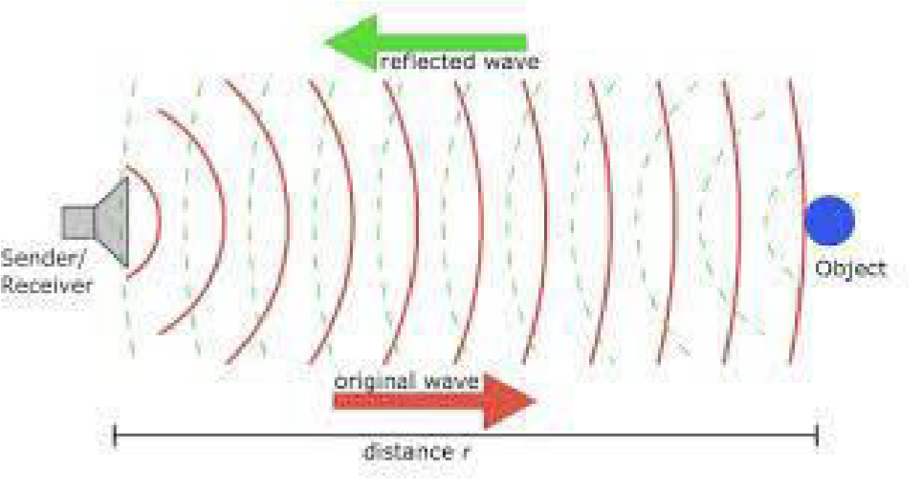

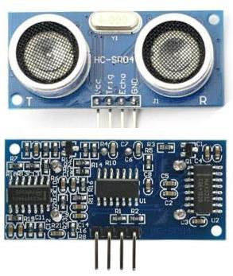

Fig 10: Ultra sonic sensor

**Technical Specifications**:

* Power Supply − +5V DC
* Quiescent Current − <2mA
* Working Current − 15mA
* Effectual Angle − <15°
* Ranging Distance − 2cm – 400 cm/1″ – 13ft
* Resolution − 0.3 cm
* Measuring Angle − 30 degree

### 3) Breadboard:

A breadboard is a construction base for [prototyping](https://en.wikipedia.org/wiki/Prototype) of [electronics.](https://en.wikipedia.org/wiki/Electronic_circuit) Originally it was literally a bread board, a polished piece of wood used for slicing bread. Because the solderless breadboard does not require [soldering,](https://en.wikipedia.org/wiki/Soldering) it is reusable. This makes it easy to use for creating temporary prototypes and experimenting with circuit design. For this reason, solderless breadboards are also extremely popular with students and in technological education. Older breadboard types did not have this property. A [stripboard](https://en.wikipedia.org/wiki/Stripboard) (Vero board) and similar prototyping [printed circuit boards,](https://en.wikipedia.org/wiki/Printed_circuit_board) which are used to build semi-permanent soldered prototypes or one-offs, cannot easily be reused. A variety of electronic systems may be prototyped by using breadboards, from small analog and digital circuits to complete [central processing units](https://en.wikipedia.org/wiki/Central_processing_unit) (CPUs).

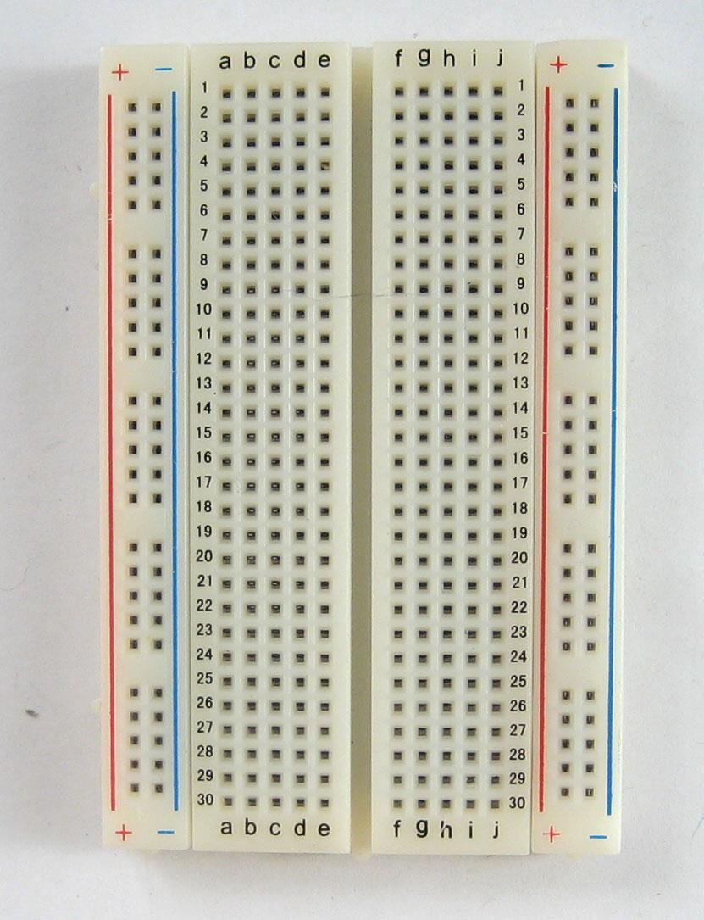

### 4) Future Enhancement:

In india, eye protective technologies has not come in Indian smart tv.So,only solution

is that protecting ourself from the rays.Sometimes during any show,because of

excitement we forget to maintain a distance from tv,with the help of this device,we

will get a notification in form of blinking light to remind us of distance.

At a particular distance,ultra sonic sensors will detect and give the input to node mcu

8266 which will let the LED to blink.In this way it is helpful for us.

**8)Refrences**

1. [www.coursera.org](http://www.coursera.org/)
2. <https://circuitdigest.com/internet-of-things-iot-projects>
3. <https://www.zapmeta.co.in/>

Code for the project-

const int trigP = 9;

const int echoP = 10;

long duration;

int distance;

void setup() {

pinMode(D0, OUTPUT);

pinMode(trigP, OUTPUT); // Sets the trigPin as an Output

pinMode(echoP, INPUT); // Sets the echoPin as an Input

Serial.begin(9600); // Open serial channel at 9600 baud rate

}

void loop() {

digitalWrite(trigP, LOW); // Makes trigPin low

delayMicroseconds(2); // 2 micro second delay

digitalWrite(trigP, HIGH); // tigPin high

delayMicroseconds(10); // trigPin high for 10 micro seconds

digitalWrite(trigP, LOW); // trigPin low

duration = pulseIn(echoP, HIGH); //Read echo pin, time in microseconds

distance= duration*0.034/2; //Calculating actual/real distance

if (distance > 70)

{

digitalWrite(D0, HIGH); // turn the LED on (HIGH is the voltage level)

delay(1000);

}

else

{ digitalWrite(D0 , LOW); // turn the LED on (HIGH is the voltage level)

delay(1000);

}

Serial.print("Distance = "); //Output distance on arduino serial monitor

Serial.println(distance);

delay(3000); //Pause for 3 seconds and start measuring distance again

}